**The Battle of Neighborhoods:**

**Differences and Similarities Across US Cities**

Sumit Maloo

Maloosumit30@gmail.com | github.com/sumit maloo

April 10, 2019

**Index**

**1. Introduction ___________________________________________________ 2**

Background

Problem and Interest

**2. Data __________________________________________________________ 3**

Description

Source

Usage

**3. Methodology ___________________________________________________ 4**

Import and Analyze Data

Map the Neighborhoods

Find Venues

Analyze Each Neighborhood

Cluster Neighborhoods

Examine Each Cluster

**4. Results ________________________________________________________ 9**

Representation: Neighborhoods per City

Typical: Most Common Cluster

Categories: Most Common Venues per Cluster

Distribution: Most Common Clusters per City

Diversity: Number of Clusters per City

Leaders: Most Common Cities per Cluster

Popular: Most Common Venues

**5. Discussion ____________________________________________________ 16**

Observations

Recommendations

**6. Conclusion _____________________________________________________** **17**

Future directions

**1. Introduction**

**1.1 Background**

As more and more people live in cities, it is also expected to see a growing number of restaurants, shops, parks, clubs, etc. – as these venues are considered indispensable in most urban areas. With that, we also expect a certain level of variation and diversity among venue types in each city, and even in each neighborhood, which is largely influenced by the interests and preferences of its community. For example, in Miami – a city with strong Latino communities – we are likely to see a higher frequency of Latino restaurants than in the Midwestern city of Des Moines. Similarly, in Downtown L.A., it is expected to find more designer showrooms in the Fashion District than in the Civic Center.

**1.2 Problem and Interest**

This project aims to find similarities of neighborhoods across seven US cities based on information about their venues. Knowledge on the distribution of such venues allows tourists to visit regions with a higher concentration of historic/famous sites, new families to buy homes closer to recreation centers and schools, and entrepreneurs to find the best area for their businesses.

**2. Data**

**2.1 Description**

Data that contributed to determining the similarities of neighborhoods across cities include a list of the neighborhoods themselves, their geolocations, the types of venues in each location, and the frequency of each venue type.

**2.2 Source**

The seven cities (Atlanta, Denver, Houston, Minneapolis, Manhattan - New York City, San Francisco, and Seattle) were non-randomly chosen by me – trying to have a diverse selection of large cities from various parts of the country. The list of neighborhoods and their geolocations (latitude and longitude) were collected from each city’s governmental pages and Google Maps, respectively. With that, I created GeoJSON files for each city on GeoJSON.io and combined them all into one larger file called “neighborhoods-map.geojson” – which is now available on my GitHub page. With Python, the venues list and their information (such as geolocation and type) were scraped from Foursquare and combined into one table. There was not a lot of missing values, so I decided to delete those from the dataset later on.

**2.3 Usage**

The coordinates in the GeoJSON file were used to create maps and markers with Folium, a Python library: one showing all neighborhood names and their cities, and another showing them divided into clusters. The tables made with data from Foursquare API were utilized to create frequency and cluster tables on Python, that were later analyzed on the statistical software JMP.

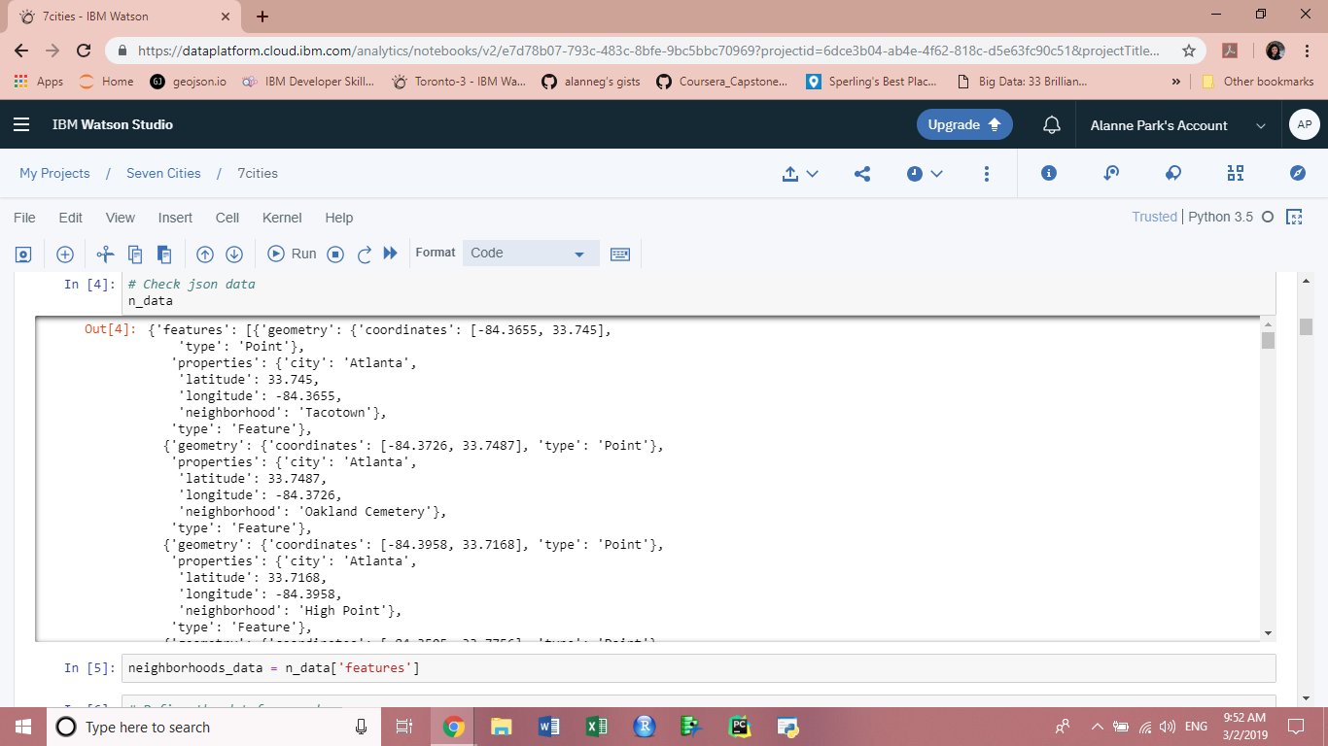

Image 1. Data collected from the GeoJSON file.

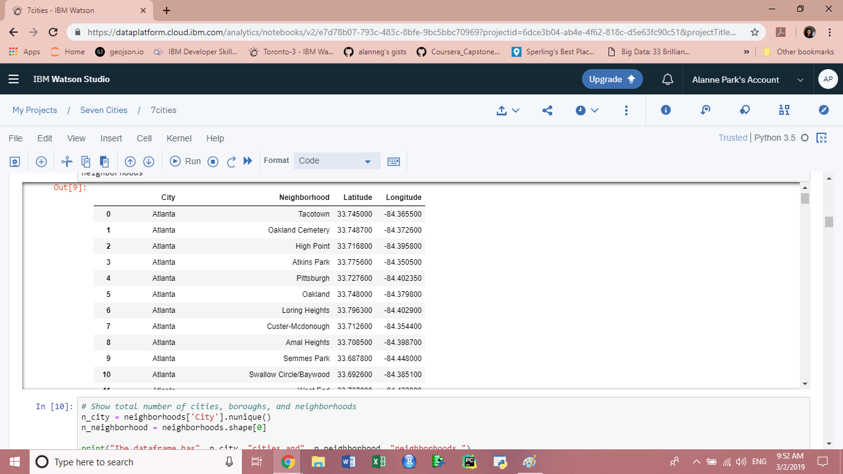

Image 2. GeoJSON data transformed into Pandas dataset.

**3. Methodology**

**3.1 Import and Analyze Data**

Them first step was to import the “neighborhoods-map.geojson” file from my Gists into the Jupyter Notebook. After opening and quickly checking the data, as shown in Image 1 above, a Pandas data frame (“neighborhoods”) was created, as shown in Image 2. For that, the “features” information was passed into the newly created columns ‘City’, ‘Neighborhood’, ‘Latitude’, and ‘Longitude’. A summary of the data frame showed that it had 7 cities and 532 neighborhoods.

**3.2 Map the Neighborhoods**

Once the data frame was created, it was possible to visualize it in a map format. A geolocator was used to find U.S.’s coordinates (39.7837304, -100.4458825), and Folium used that information to map and show all seven cities in one single map. Also, markers were created for each neighborhood, detailing its name and city.

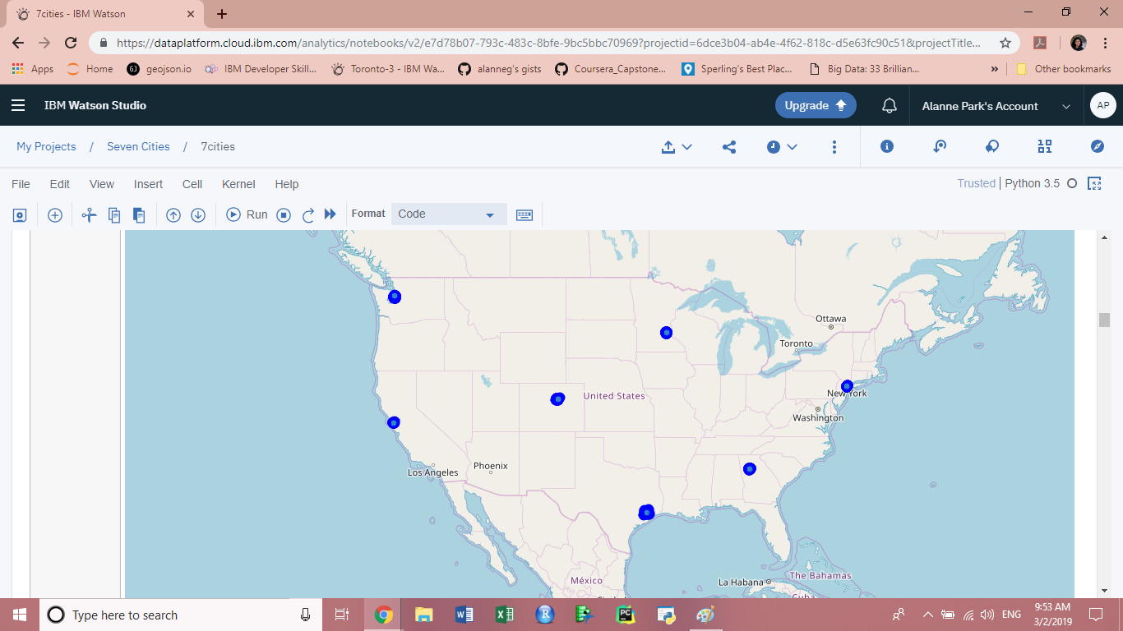

Figure 3. U.S. map showing all the seven cities.

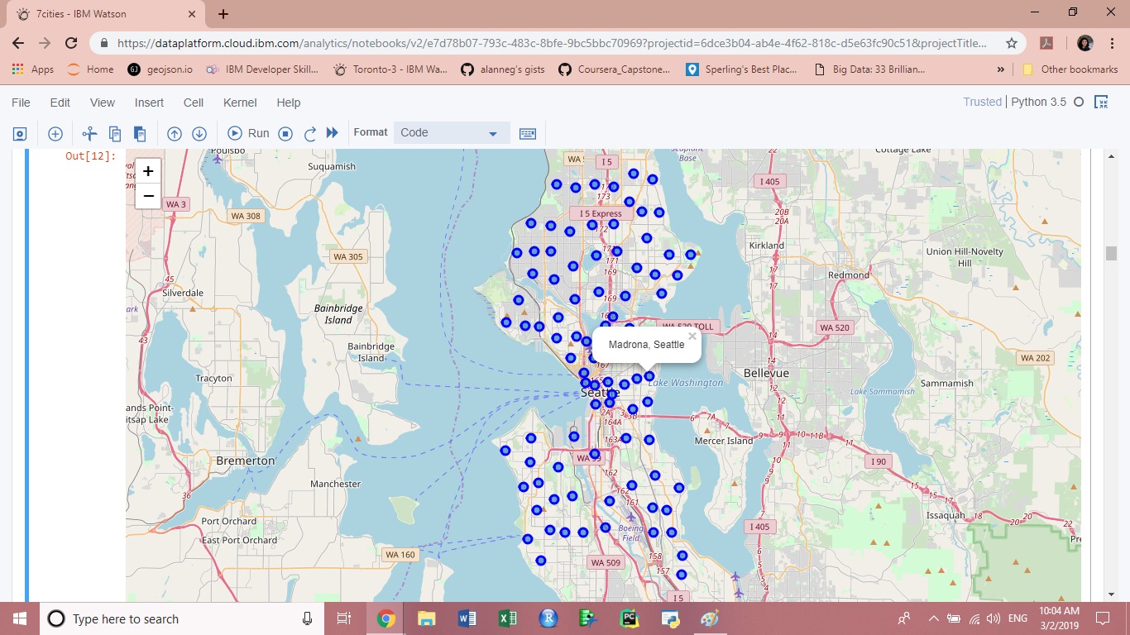

Figure 4. U.S. map zoomed in Seattle, showing the neighborhood of Madrona.

**3.3 Find Venues**

For this part, Foursquare API was utilized to collect information on each neighborhood’s venues based on their coordinates. Also, a function was created to extract the category of each venue. As this data was imported in JSON format, another data frame (“nearby_venues”) was created with valuable information into neighborhood and venue columns, as shown in Figure 5.

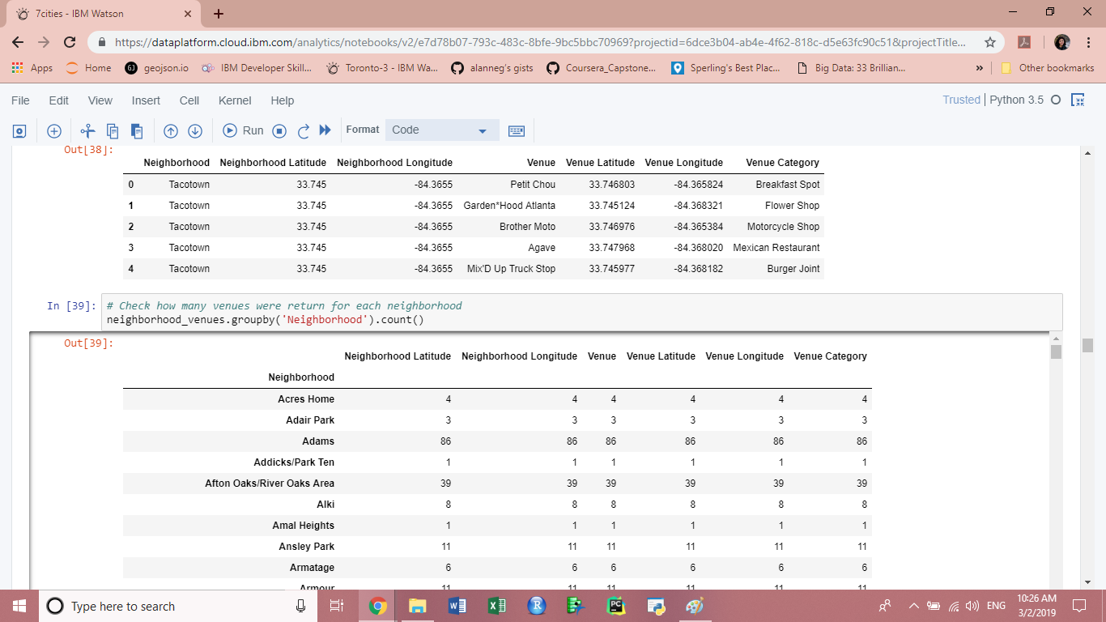

Figure 5. Data frame on neighborhoods and their venues.

A quick summary of the table above showed that information on a total of 11,201 venues was collected. Later, the number of venues returned for each neighborhood was also observed, as well as the number of unique venue categories: 477.

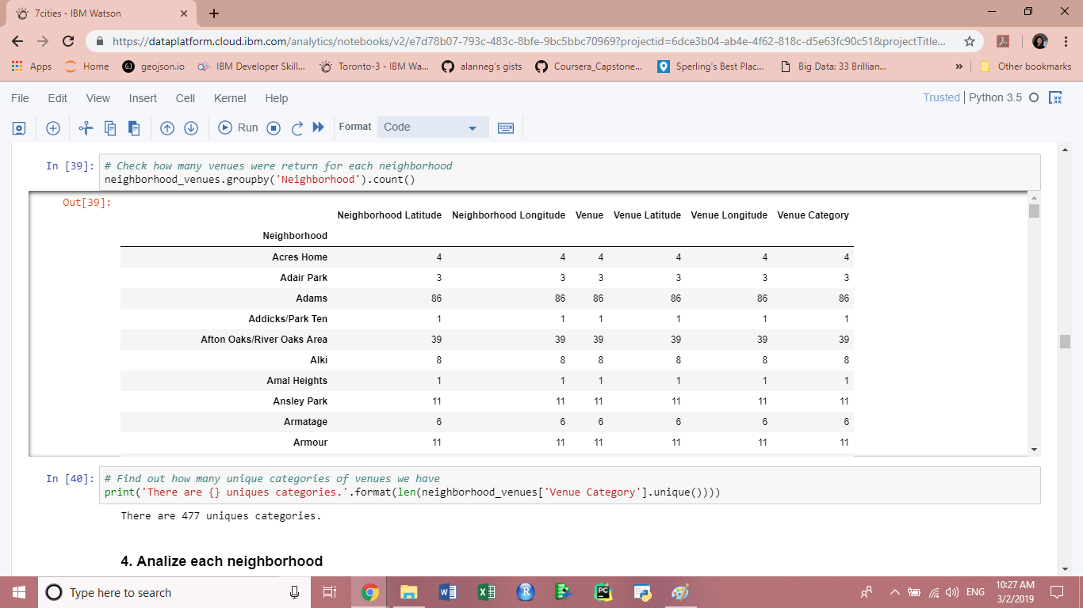

Figure 6. Data frame of venues per neighborhood.

**3.4 Analyze Each Neighborhood**

To look deeper into each individual location, the first step was to group rows by neighborhood and take the mean of the frequency of occurrence of each category. Then, a new data frame displayed the top 10 most common venues for each location (“neighborhoods_venues_sorted”).

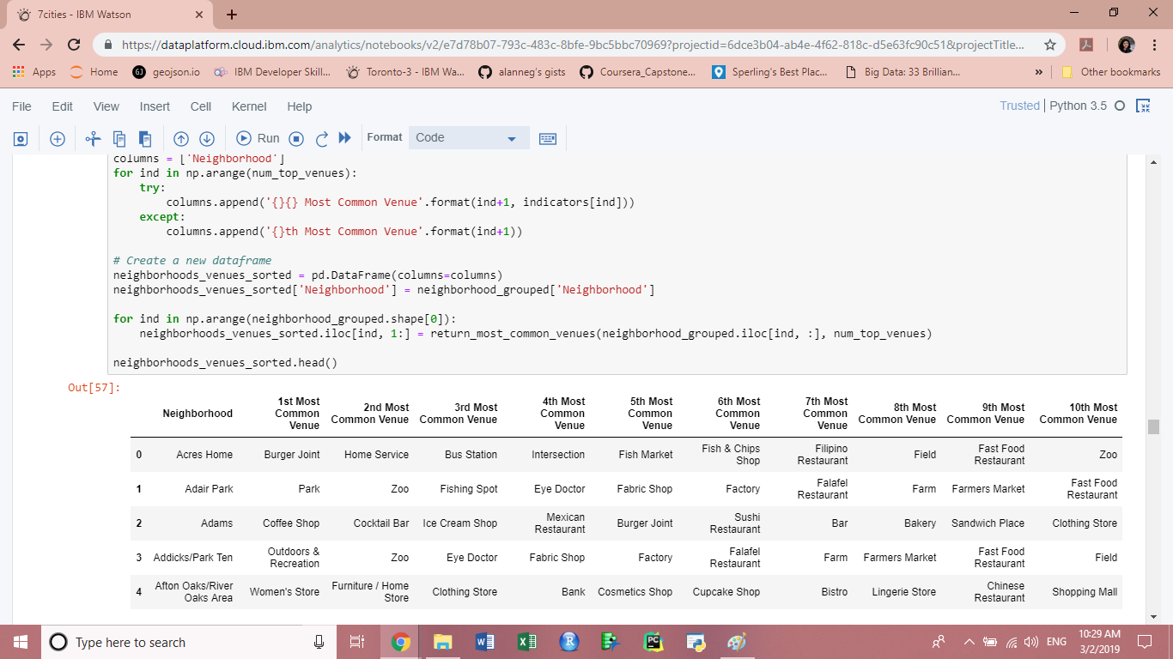Figure 7. Data frame of the top 10 most common venues per neighborhood.

**3.5 Cluster Neighborhoods**

For this part, k-means was used to cluster neighborhoods based on their most common venues. After trying a variety of cluster numbers, I decided to set 10 as the number of clusters in which the neighborhoods would be grouped. Then, a new data frame (“neighborhood_merged”) was created to include the cluster as well as the top 10 venues for each neighborhood. And from that, it was possible to visualize the different clusters in another Folium map (as seen in Figure 8 below).

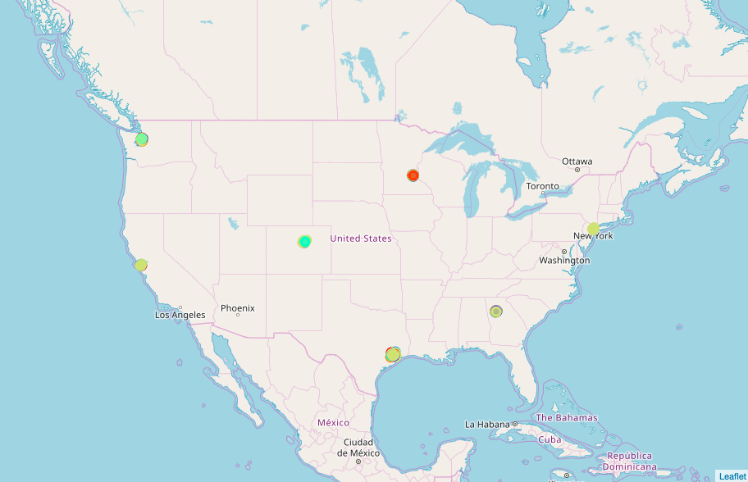

Figure 8. U.S. map showing clusters in all seven cities.

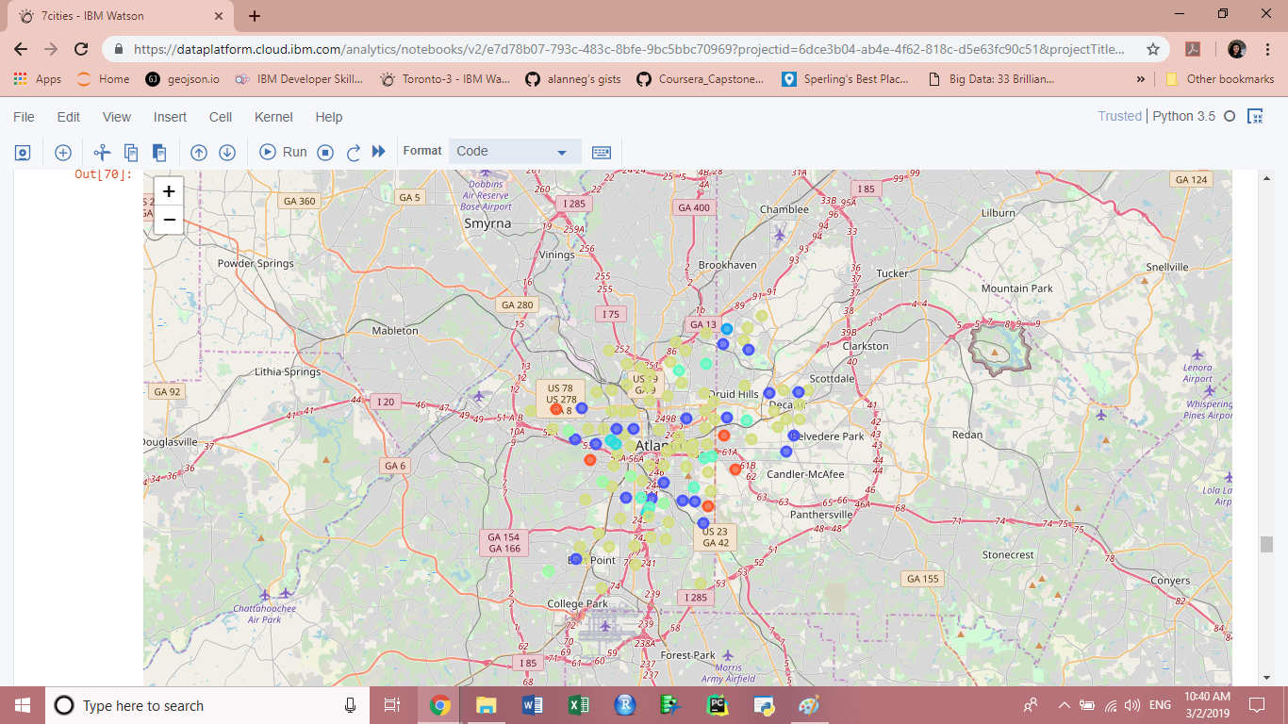 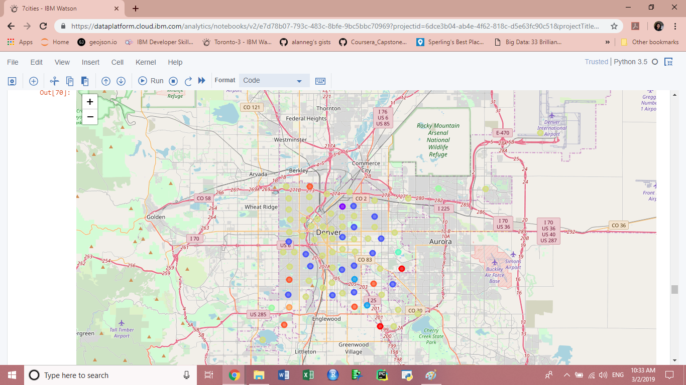

Figure 9. Clustered map zoomed in Atlanta. Figure 10. Clustered map zoomed in Denver.

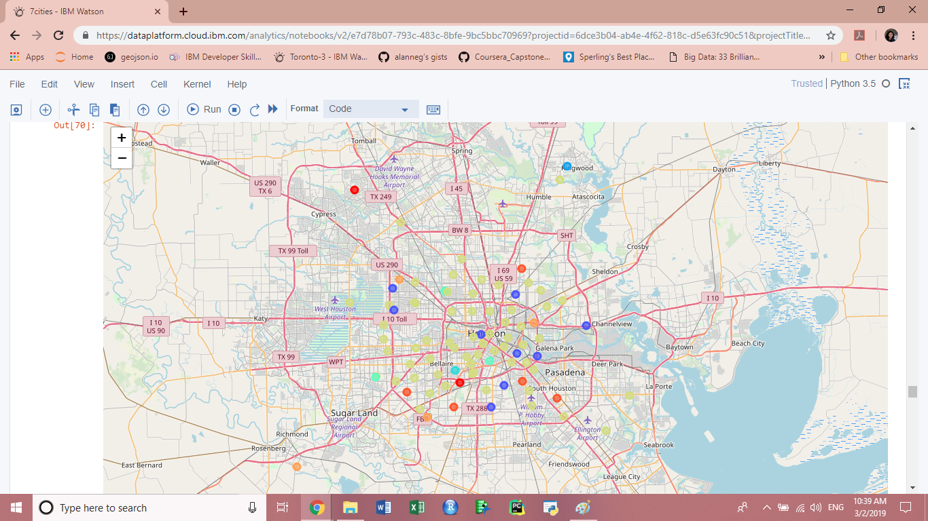 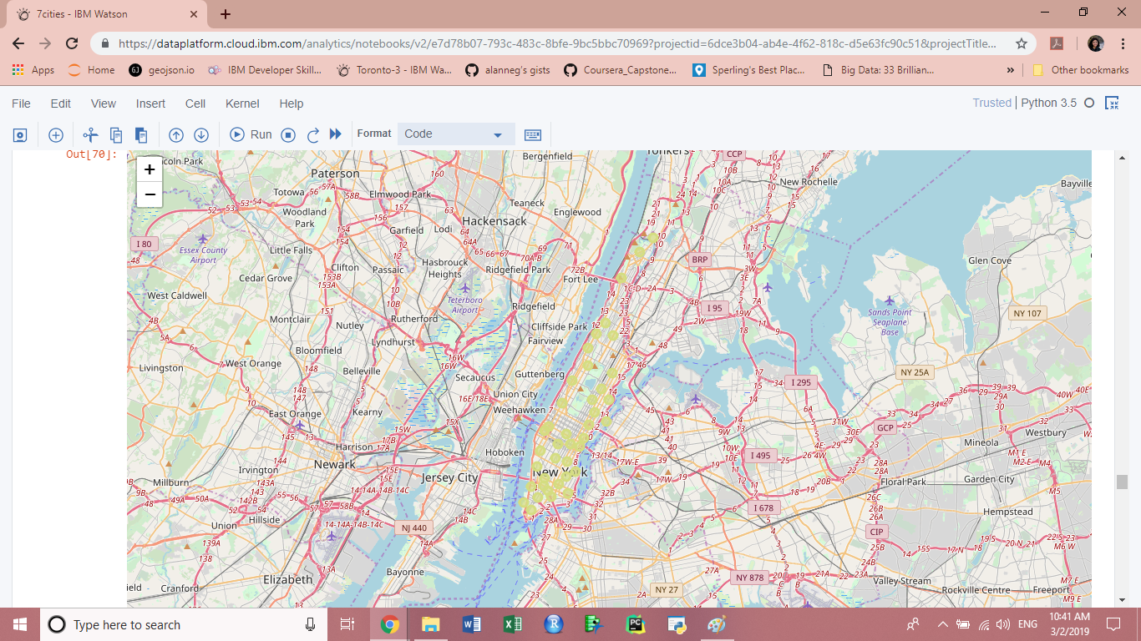

Figure 11. Clustered map zoomed in Houston. Figure 12. Clustered map zoomed in Manhattan - NYC.

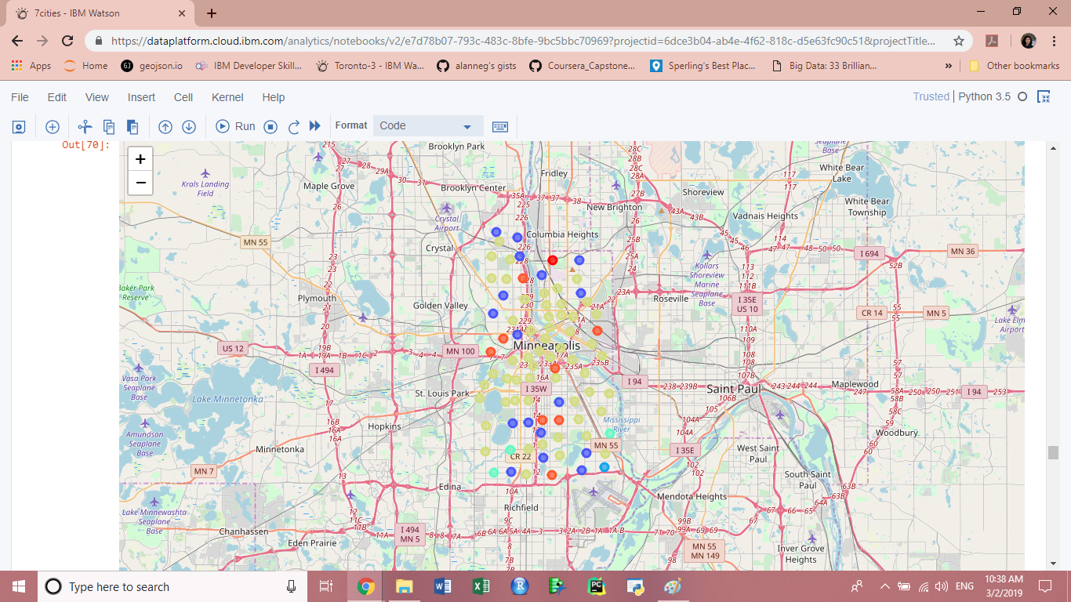 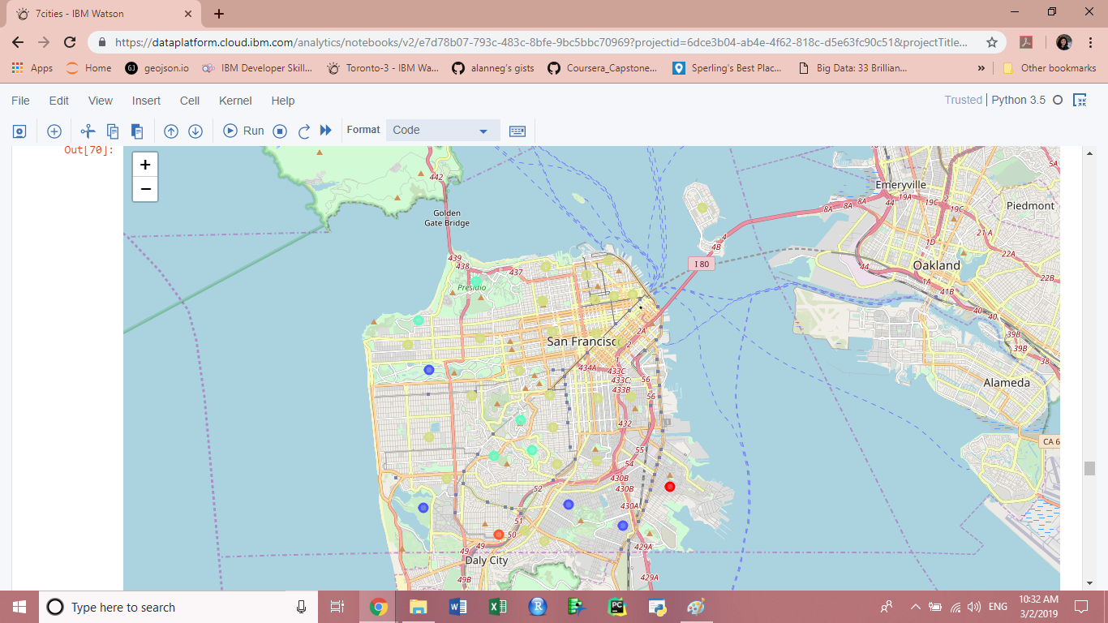

Figure 13. Clustered map zoomed in Minneapolis. Figure 14. Clustered map zoomed in San Francisco.

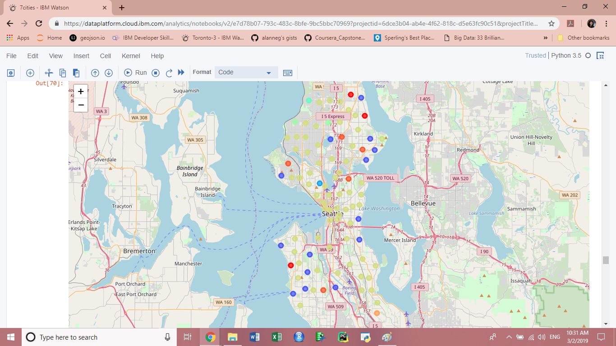

Figure 15. Clustered map zoomed in Seattle.

**3.6 Examine Each Cluster**

As a final step, separate tables were created for each of the 10 clusters – making it easier to identify their most common venues and to find the similarities among their neighborhoods. Other than that, just like figures 9 to 15 give a hint of how clusters are distributed across cities, these tables show the difference in size across clusters – since some have more or fewer neighborhoods, as exemplified below with clusters 2 and 9.

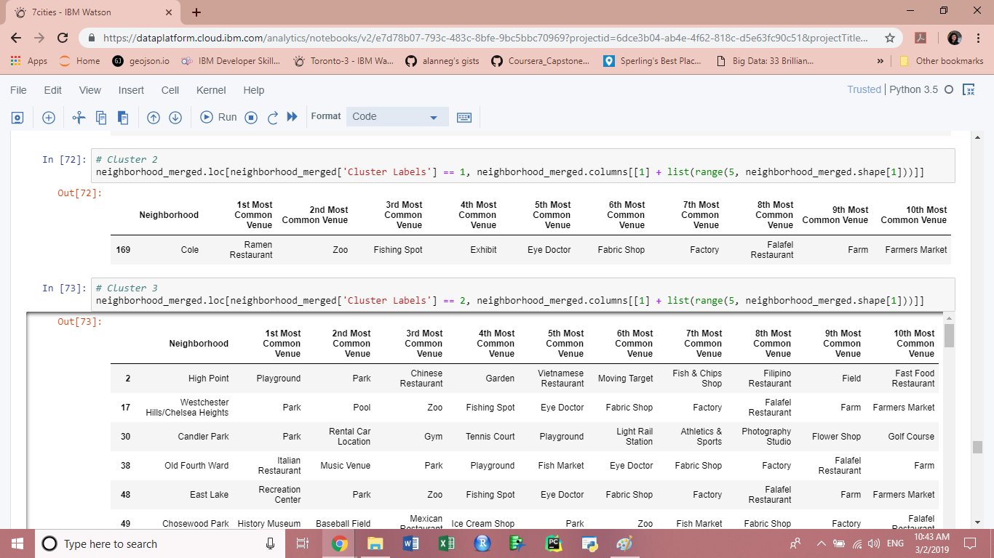

Figure 16. Table for clustered 2.

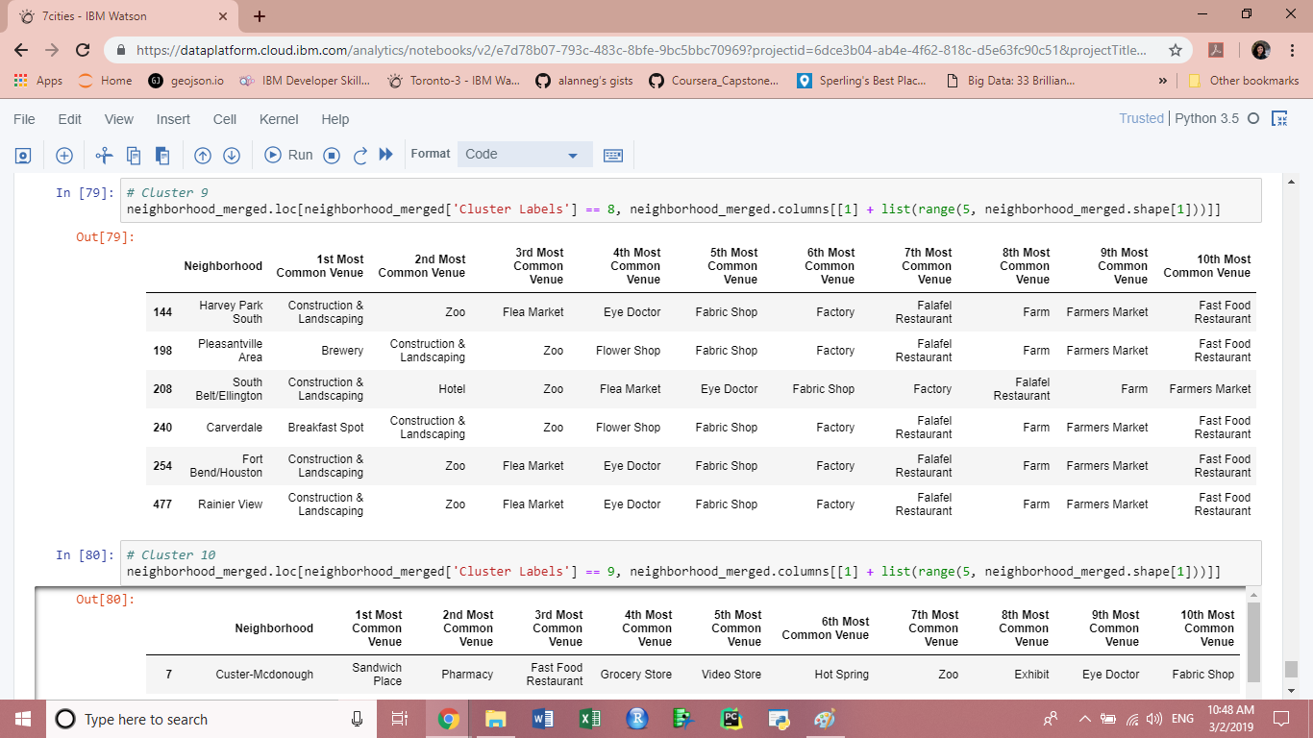

Figure 17. Table for clustered 9.

**4. Results**

**4.1 Representation: Neighborhoods per City**

As a result of choosing cities with no specific requirements, it was expected that their features would not be the same. In this case, an important difference between the seven cities is the number of neighborhoods each of them has. This difference, combined with the fact that the population per neighborhood was not considered in this study, makes it is possible that some locations were overrepresented (as we can see in Figure 18 below).

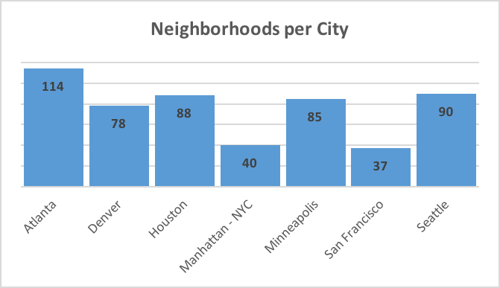

Figure 18. Distribution of neighborhoods per city.

**4.2 Typical: Most Common Cluster**

When it comes to the distribution of clusters across the different cities, it is clear in the graph below (Figure 19) that there is a huge disparity. While most clusters include only 1 to 10 neighborhoods, cluster 8 has an exorbitant total of 366 neighborhoods. At first, this can be seen as an error when choosing the number of clusters, but after having a closer look (Table 1), it will be clear that the diversity of that cluster – as well as its most common venue types – make it plausible that so many “big-city neighborhoods” would be added to it.

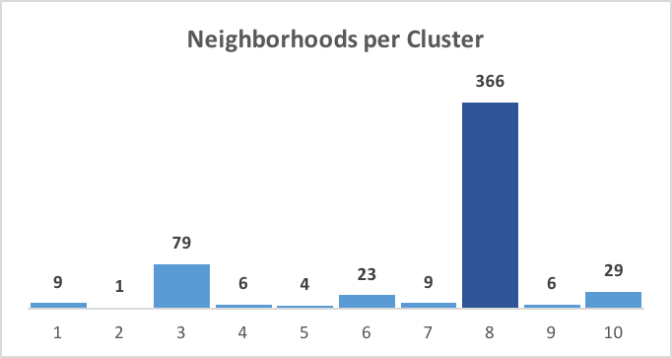

Figure 19. Distribution of neighborhoods per cluster.

**4.3 Categories: Most Common Venues per Cluster**

Table 1 below shows the frequency of 1st most common venue types per cluster. This means that when looking at the 1st most common venues of all neighborhoods in a cluster, certain venue types were largely more represented than others. We could then say that a neighborhood having these as their most common venue types are likely to be grouped on a certain cluster – still, it is important to consider the frequency values. On Table 1, it is clear that ‘park’ and ‘trail’ are popular venues across different clusters, but the variation in frequency shows that some clusters are more diverse than others.

For example, 100% of neighborhoods in cluster 5 has ‘trail’ as their most common venue. But when it comes to cluster 6, the 61% frequency shows that at least 39% of its neighborhoods has another venue type as their most frequent. To explain why those on the 61% from cluster 6 were not included in cluster 5, it is plausible to assume that their second or third most common venues fall on the same category as the first most common venue of that 39% left behind – while the second and third most common value of that 100% from cluster 5, might be totally different.

So, the frequencies below show not only the predominant venue types but also how important the second, third, and so forth most common venue types affect which neighborhoods will be included in that cluster. The fact that cluster 8 (the one with more neighborhoods in it) has coffee shops at an 11% frequency rate indicates that it is the most diversified cluster, and that its second and third most common venues might have played a large role on which neighborhoods were included.

|  |  |  |
| --- | --- | --- |
| **Cluster** | **Venue** | **Frequency** |
| 1 | Gym | 22% |
| Pool | 22% |
| 2 | Ramen Restaurant | 100% |
| 3 | Park | 29% |
| 4 | Playground | 83% |
| 5 | Trail | 100% |
| 6 | Trail | 61% |
| 7 | Park | 100% |
| 8 | Coffee Shop | 11% |
| 9 | Construction & Landscaping | 67% |
| 10 | Grocery Store | 17% |
| Coffee Shop | 17% |

Table 1. The frequency of 1st most common venues per cluster.

**4.4 Distribution: Most Common Clusters per City**

On the images below, we can see which clusters are more represented in each city. Similar to what we saw in Figure 18, the fact that the population per neighborhood and the neighborhood dimensions were not considered in this study, makes it is possible that some clusters were overrepresented.

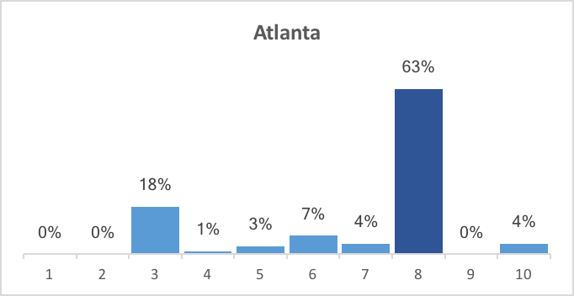 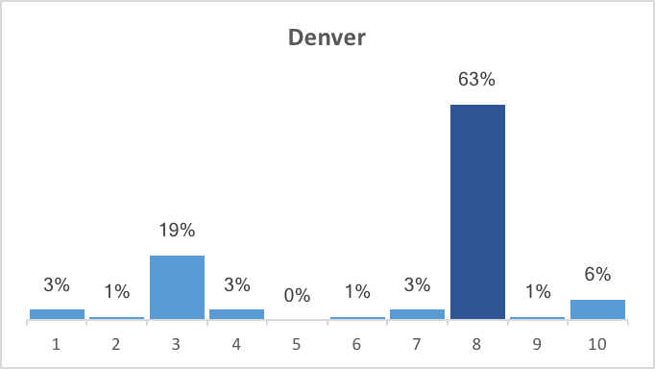

Figure 20. Cluster percentages in Atlanta. Figure 21. Cluster percentages in Denver.

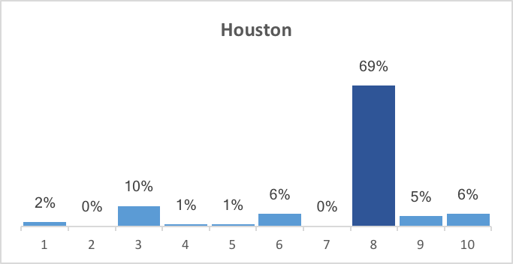 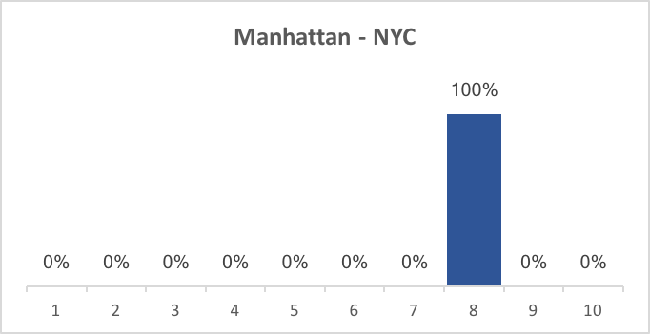

Figure 22. Cluster percentages in Houston. Figure 23. Cluster percentages in Manhattan - NYC.

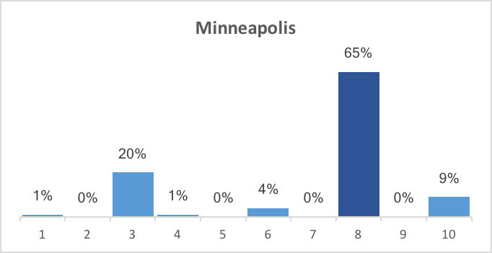 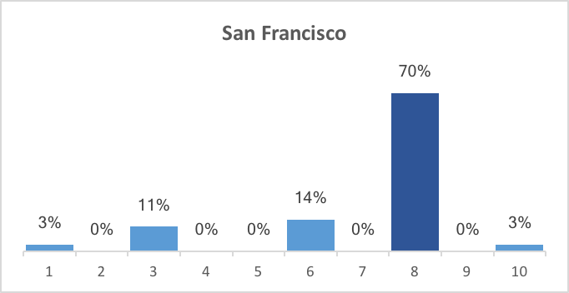

Figure 24. Cluster percentages in Minneapolis. Figure 25. Cluster percentages in San Francisco.

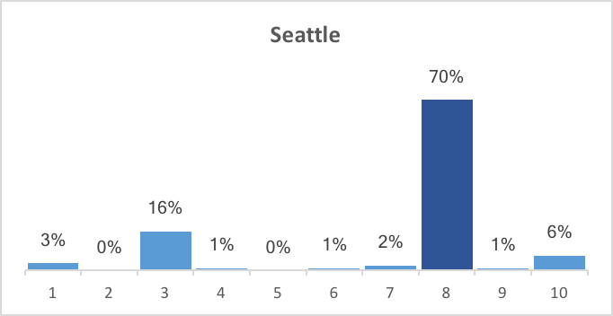

Figure 26. Cluster percentages in Seattle.

**4.5 Diversity: Number of Clusters per City**

To see which cities are more diverse, or at least which ones have neighborhoods with the least similarities in venue types, we can check the distributions below. It is clear that Manhattan - NYC is the least diverse, with all of its neighborhoods included in the same cluster, when compared to the other six cities. As Denver shows the largest number of unique clusters, we can say it is the most diverse of the seven cities chosen for this study.

|  |  |  |
| --- | --- | --- |
| **City** | **Clusters** | **Count** |
| Atlanta | 3, 4, 5, 6, 7, 8, 10 | 7 |
| Denver | 1, 2, 3, 4, 6, 7, 8, 9, 10 | 9 |
| Houston | 1, 3, 4, 5, 6, 8, 9, 10 | 8 |
| Manhattan - NYC | 8 | 1 |
| Minneapolis | 1, 3, 4, 6, 8, 10 | 6 |
| San Francisco | 1, 3, 6, 8, 10 | 5 |
| Seattle | 1, 3, 4, 6, 7, 8, 9, 10 | 8 |

Table 2. The number of unique clusters per city.

**4.6 Leaders: Most Common Cities per Cluster**

On the images below, we can see which cities are more represented in each cluster. Similar to what we saw in Figures 20 to 26, the fact that the population per neighborhood and the neighborhood dimensions were not considered in this study and the clusters have different sizes, makes it is possible that some cities were overrepresented.

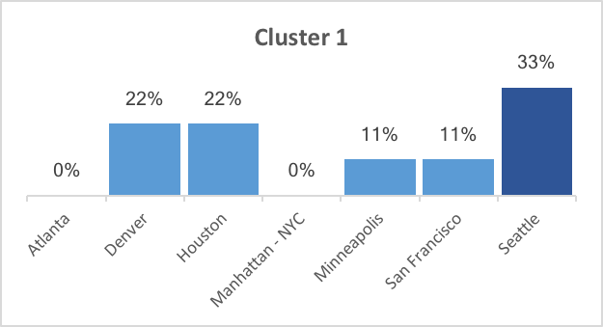 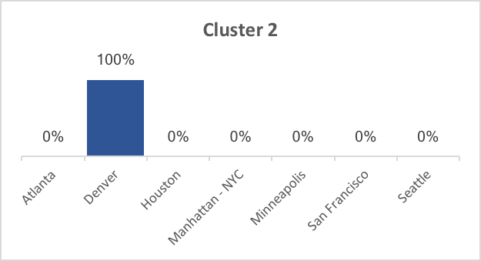

Figure 27. City percentages in Cluster 1. Figure 28. City percentages in Cluster 2.

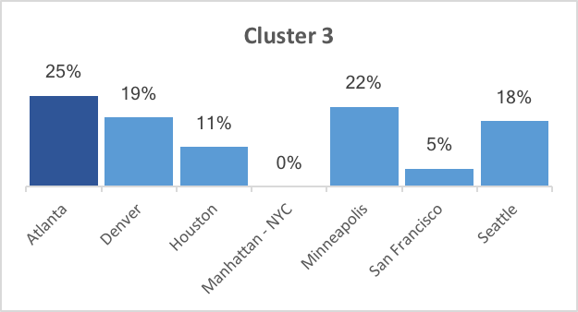 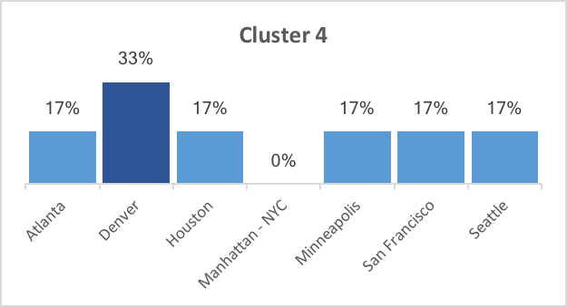

Figure 29. City percentages in Cluster 3. Figure 30. City percentages in Cluster 4.

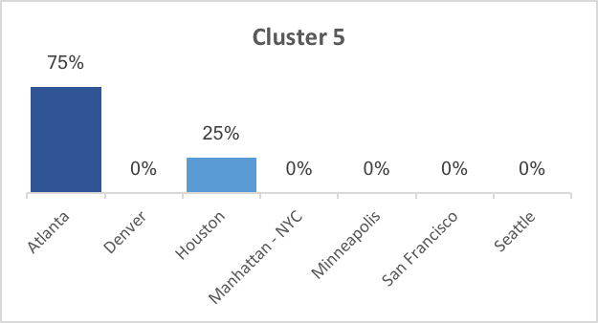 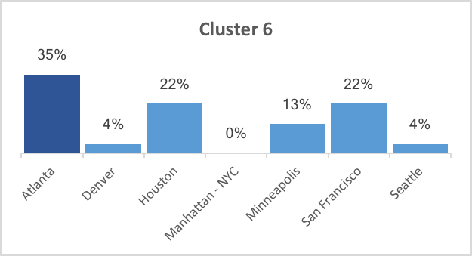

Figure 31. City percentages in Cluster 5. Figure 32. City percentages in Cluster 6.

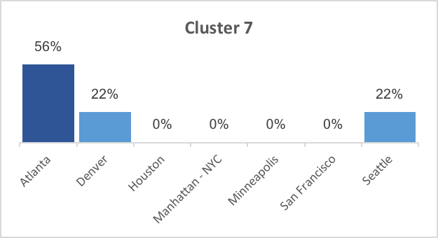 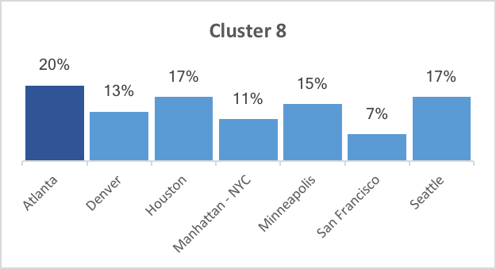 Figure 33. City percentages in Cluster 7. Figure 34. City percentages in Cluster 8.

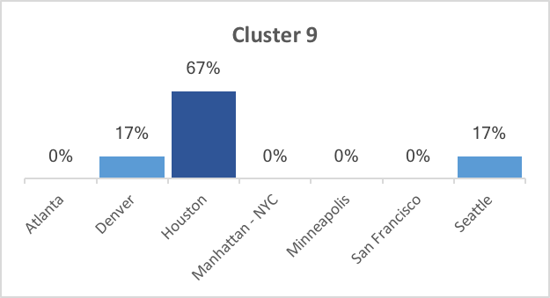 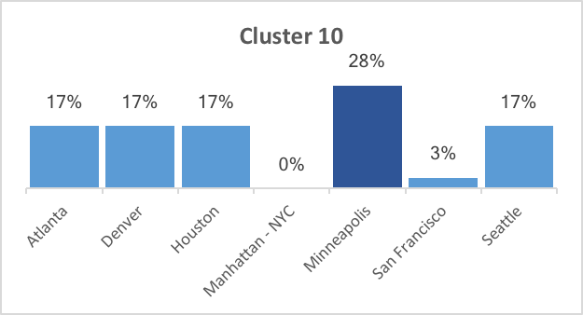

Figure 35. City percentages in Cluster 9. Figure 36. City percentages in Cluster 10.

**4.7 Popular: Most Common Venues**

Below we can see the most common venue types in each city. Similar to what we saw in Table 1, the frequencies below show not only the predominant venue types but also how diverse each city is – the smaller the frequency of its most common venues, the more diverse it is overall.

|  |  |  |
| --- | --- | --- |
| **City** | **Venue** | **Frequency** |
| Atlanta | Park | 15% |
| Trail | 8% |
| Denver | Park | 13% |
| Pizza Place | 5% |
| Houston | Burger Joint | 6% |
| Fast Food Restaurant, Hotel, Mexican Restaurant | 5% |
| Manhattan - NYC | Italian Restaurant | 28% |
| Coffee Shop | 23% |
| Minneapolis | Coffee Shop | 12% |
| Park | 8% |
| San Francisco | Park | 22% |
| Coffee Shop, Trail | 11% |
| Seattle | Coffee Shop | 18% |
| Park, Bus Stop | 6% |

Table 3. The frequency of 1st and 2nd most common venues per city.

Another interesting takeaway of this study is the apparent normal distribution of the number of categories per ‘common venue’ level. As seen in Figure 37 below, there are less unique venue categories for the first, second, ninth, and tenth most common venues. This means that the most and least common venues in our locations are more similar – less diverse – than the middle (third to eight) common venues. One could then conclude that those middle venues are quite significant to determine what makes a neighborhood or city unique.

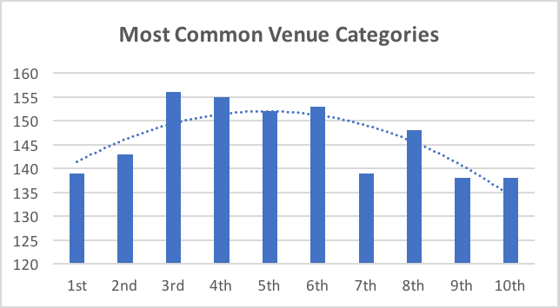

Figure 37. Distribution of categories per most common venues.

**5. Discussion**

**5.1 Observations**

With the analysis above, we can make assumptions on how diverse cities are when compare to each other, how neighborhoods are similar overall, and what kind of venues are more common in each neighborhood and city.

* The most common cluster is number 8, with 366 neighborhoods – almost 69% of the total.
* Atlanta has the largest number of neighborhoods (114), while Manhattan has the smallest (40).
* Denver is considered the most diverse city, showing 9 different clusters. While Manhattan is the most uniform, with only 1 cluster.
* The most common cities per cluster are Seattle, Denver, Atlanta, Denver, Atlanta, Atlanta, Atlanta, Atlanta, Houston, and Minneapolis, respectively.
* The most common venues per cluster are gyms, ramen restaurants, parks, playgrounds, trails, trails, parks, coffee shops, construction, and grocery stores, respectively.
* The most common venues per city are parks (Atlanta, Denver, and San Francisco), burger shops (Houston), and coffee shops (Manhattan - NYC and Seattle).
* Overall, the most common “first most common” venues are coffee shops and parks (1st), trails (2nd), pizza places, Mexican restaurants, and Italian restaurants (3rd).
* Overall, the most common “second most common” venues are coffee shops, parks, and zoos.

**5.2 Recommendations**

According to the above observations and the overall analysis on part 4, active families and individuals might prefer moving to Atlanta, Denver or San Francisco, as these areas have more outdoor space than the others. Those who love eating out might – especially American fast food – would prefer Houston, while Manhattan - NYC and Seattle seem to be a good fit for those with fast-paced lives and who like a more urban environment.

Although tourists might enjoy visiting all cities, they might have better expectations on what they will find in each of them, and in which neighborhoods might find their preferred experiences. Similarly, different companies might find advantages in various locations. Still, we could infer that businesses focused on the different groups mentioned above would be more successful in the cities and neighborhoods they are most likely located.

**6. Conclusion**

Based on this study we can conclude that venue type and presence is a significant factor when grouping and comparing locations, and that Foursquare API is a useful tool for the task. It is also clear that, although cities seem to have similar “most common venues”, there is not a singular or unique way in which those places are distributed in urban areas. Nonetheless, it is important to consider not only the first or second most common venue types, but to actually look into at least the top ten most frequent in order to have a good idea of a neighborhood’s identity.

**6.1 Future Directions**

Although this study introduces a good start for the comparison of neighborhoods and cities, to effectively find and recommend the best locations for specific clients, it would be necessary to add important variables to the analysis – such as population numbers, real estate prices, crime rates, weather, and cultural characteristics – depending on the desired goal.